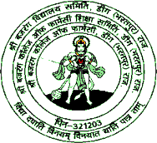
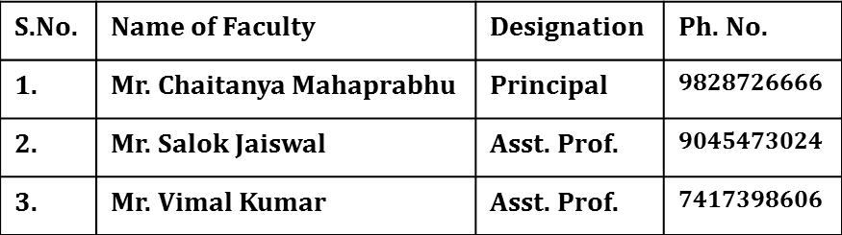
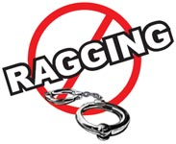
SHRI BAJRANG COLLEGE OF PHARMACY
Bhuda Gate, Deeg, Bharatpur (Raj.)
Approved by AICTE, PCI & Affiliated to RUHS, Jaipur (Raj.)
DON’T ‘RAG’
Also
DON’T BE A
MUTE WITNESS TO ‘RAGGING’
What is Ragging ?
Any act resulting in :
- Mental/Physical/Sexual abuse
- Verbal abuse
- Indecent Behaviour
- Criminal intimidatiom/Wrongful restraint
- Undermining human dignity
- Financial exploitation/Extortion
- Use of force
Each of the above is a criminal offence
ANTI-RAGGING SQUAD
A Student involved in ragging be :
- Expelled from the institution
- Banned from the mess/Hostel
- His/her Scholarship can be withdrawn
- Debarred from examinations
- Denied admission to any institution
- Prosecuted for criminal action
- Institutions to file FIR with local police against
Those who RAG/ABET ragging
Join Hands to Make Ragging Free Campus

